**24.3.1**

Hi Benny, What are you doing?

I’m looking at football scores

**Did your team win?**

No, They didn’t win.But they didn’t lose.

So you didn't beat anyone but you didn't lose? I'm confused

It was a tie. The score was one to one. One of the players on my club scored a goal. And another player on another club scored

It's weird that no winner

It happens overtime.

Wow

Come in.

Benny. Do you hear the news? The store down this street. It sells new video game. Ram war 5-0

Really?

Thursday , That’s today.

Yes It only sell to buy tommorrow._

It said It costs 55$.

LiLi , How long is it the wait?

Right now , 2 hours , I’m going to get it this afternoon.

What are the best about this game?

Are you serious ?You find all of this in the city.

Shen. Do you want to play game with me?

No

Why not?

Because I’m going to see Marty. We are going to talk about job for me.

Hi Paz

He Shen.

Can you help me with my couch?

Yes. I have to go now

What is Benny looking at?

->Football scores

Why is Shen confused?

-> He doesn’t understand what a tie is.

Li Li is excited because a new game is now on sale.

Why does Shen say he can’t go with Li Li?  
-> He is going to meet Marti.

**Practice**

He is the best player on the team.

At the end of the game , the score was three to one.

The winner of the game get’s $100

They do not want to lose the basketball game.

The blue team always wins the games.

My favorite player is Donald Ranger.

The score was one to one . It was a tie.

One of the players on my club scored a goal.

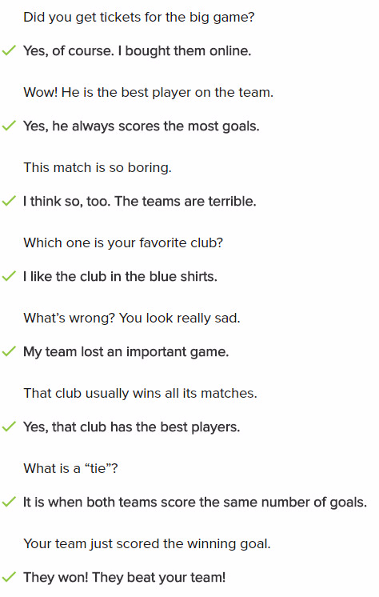

**Conversation**

Hi Shen, do you want to come the basketball game?

No, I don't want to go. Last time we waited in line for two hours.

But I really like the players on the team. You will go early, we can get tickets

Last time, we didn't get tickets. Can you buy ticket online?

I'll check. This team won the serious class second, so they are very famous. It's a NY nick

We watched them player game on TV last weekend. They tie with the other team.

But tonight is a diffirent game. Look, we can buy ticket online. Are you sure you don’t want to come?

Okay, let’s go to the game. I hope your team win!

**Exercise**

The players look really sad because they lost the game.

The player scored a goal.

Brent: Which team won the game?

-> Lucy: No team won. It was a tie.

I like #6 and #22. They are my favorite players.

The players look really sad because they lost  the game.

The red team beat the yellow team, so the red team is the winner.

Please check your ticket .What time does the game start?

Jena: I am sure the Reds are going to win!

-> Saad: No way! I know the Greens are going to beat the Reds.

He scored a goal! Our club won!